Mammal, Cat and Human classes example:

A Cat and a Human inherit characteristics and behaviours from Mammal.
 In diagrams arrow points to the PARENT class.
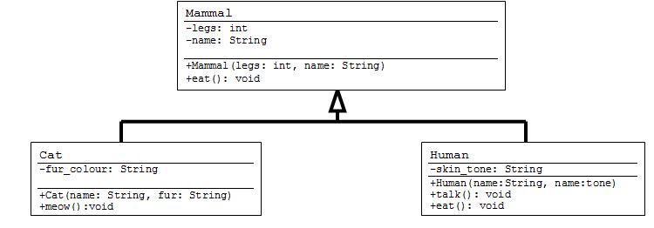

// The "Mammal" class.  public class Mammal{  private int legs;  private String name;  private boolean hungry;  public Mammal(int l, String n){  legs = l;  name = n;  }//end constructor  public void eat(){  hungry = false;  }  }//end class | // The "Cat" class.  public class Cat extends Mammal{  String fur_colour;  public Cat(String name, String fur){  //calls the parent’s classes constructor  super(4, name);  fur_colour = fur;  }//end constructor  public void meow(){  System.out.println(“Meeeeeowwwwwww!”);  }  }//end class
// The "Human" class.  public class Human extends Mammal{  String skin_tone;  public Human(String name,String tone){  //calls the parent’s classes //constructor  super(2, name);  skin_tone = tone;  }//end constructor  public void eat(){  //calls parent’s eat() method  super.eat();  System.out.println("yum yum!");  }  public void talk(){  System.out.println(“hello!”);  }  }//end class | // The “Main” class  public class Main{  public static void main(String args[]){  Human vlad = new Human(“Vlad”, “grey”);  Human varun = new Human(“Varun”, “blue”);  Cat felix = new Cat(“Felix”, “yellow”);  Cat garfield = new Cat(“Tom”, “orange”);  vlad.talk();  felix.meow();  vlad.eat();  felix.eat();  }  }//end class

Explanation:

Mammal is the parent or super class of Cat and Human classes
Cat and Human class are child or sub classes of Mammal class
Cat & Human Classes inherit all the variables and methods from Mammal class
The keyword super calls the parent class
- You call a Parent’s constructor by using the keyword super in the constructor
Both Human and Cat have a call to super in their constructors
· Human constructor → super(2, name);
· Cat constructor → super(4, name);

- You can call parent’s methods, by using the keyword super
Human class call parent’s method eat() by using word super and add own behaviour by adding more code.
· The human class has own method eat: → public void eat()
· The parent’s version of eat is called first → super.eat();
· New code is added to customize eat() method for the human classà System.out.println("yum yum!");

