OOP definitions. More OO examples. Polymorphism.
A class is a template for creating objects, such that an object is an instance of its class. A class has three kinds of members:
- variables
  - variable is also called field, or data, property, attribute, state. A field name should be a noun, such as price, name.
  - a normal field is also called an instance variable, because instances of the class have this field
  - a static field is also called a class variable, because this field is available without having to instantiate an object
- constructor, which initializes a newly-created object. The constructor looks like a method, but it has no return type and its name matches the class name, such as Toy()
- method, or behavior. A method name should be a verb, such as getPrice()
An object is an instance of a class.
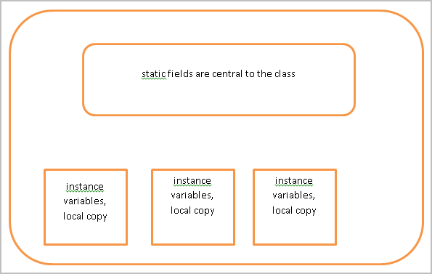

Default constructor and default values for fields

class Stereo{
boolean myBool;
int myInt;
double myDouble;
char myChar;
String myString;
// no constructor defined, so default constructor
}
class DefaultConstructorDemo{
public static void main(String[] args) {
Stereo s = new Stereo();
System.out.println(s.myBool);
System.out.println(s.myInt);
System.out.println(s.myDouble);
System.out.println("the default char value is a blank space:" + s.myChar + ".");
System.out.println(s.myString);
}
}
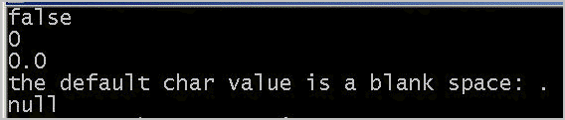

Multiple objects can point to same place in memory

Although each object has its own copy of the instance variables (fields) of its class, if an object is set to reference another object, both objects point to the same location in memory.
Let's try this with objects of type Apple.
class Apple{
String color = "red";
int weight = 50;
boolean isEdible = true;

void setColor(String c) {
this.color = c;
}
void setWeight(int w) {
this.weight = w;
}
void setEdible(boolean b) {
this.isEdible = b;
}
}
class ReferenceTest{
public static void main(String[] args) {
Apple a1 = new Apple();
System.out.println(a1.color);
System.out.println(a1.weight);
System.out.println(a1.isEdible);

Apple a2 = new Apple();
a2.setColor("green");
a2.setWeight(100);
a2.setEdible(false);
System.out.println(a2.color);
System.out.println(a2.weight);
System.out.println(a2.isEdible);

a1 = a2;
System.out.println("a1 now points to the same place in memory that a2 does.");
System.out.println(a1.color);
System.out.println(a1.weight);
System.out.println(a1.isEdible);
System.out.println("If I change a1 to the color yellow, does it affect a2?");
a1.setColor("yellow");
System.out.println(a2.color);
}
}
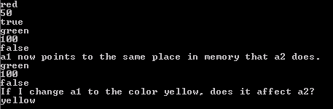

An object as a return type

A non-void method can return a primitive or an object, such as a String, an Employee, a Car, a Fraction.
For example,
public class Point{
private int x;
private int y;

public Point(int x, int y){ //constructor
this.x=x;
this.y=y;
}

public Point getOrigin(){ //method, that returns object Point
Point orig=new Point(0,0);
return orig;
}
public static Point clone(Point myPoint){
Point p=new Point(myPoint.x, myPoint.y);
return p;
}
public String toString(){
return " (" + x + "," + y + ")";
}
public void setX(int x){
this.x=x;
}

}
class PointTest{
public static void main(String[] args) {
Point p1 = new Point(3,7);
System.out.println("p1: "+p1);
Point p0 = p1.getOrigin();
System.out.println("p0: "+p0);
Point p3 = Point.clone(p1);
System.out.println("p3: "+p3);
p3.setX(100);
System.out.println("p1: "+p1);
System.out.println("p3: "+p3);
}
}
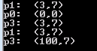
/*
* A Line composes of two Points - a begin point and an end point.
*/
public class Line {
// The private instance variables
private Point begin, end; // Object members - instances of the Point class

// Constructors
public Line(int x1, int y1, int x2, int y2) {
begin = new Point(x1, y1); // Construct the instances declared
end = new Point(x2, y2);
}
public Line(Point begin, Point end) {
this.begin = begin; // The caller constructed the instances
this.end = end;
}

// The public getter and setter for the private instance variables
public Point getBegin() {
return begin;
}
public Point getEnd() {
return end;
}

IS-A relationship and HAS-A relationship
In Line and Point example class Line has a variable of type Point. It called "has-a" relationship. In other words, "has-a" relationship is when a class contains references to other classes.
In our earlier example of Player and FunnyPlayer: FunnyPlayer is a subclass of Player. We can say that FunnyPlayer "is-a" Player (actually, it "is-more-than-a" Player). Subclass-superclass exhibits a so called "is-a" relationship.

Polymorphism
The word "polymorphism" means "many forms". It comes from Greek word "poly" (means many) and "morphos" (means form).
A subclass possesses all the attributes and operations of its superclass (because a subclass inherited all attributes and operations from its superclass). This means that a subclass object can do whatever its superclass can do. As a result, we can substitute a subclass instance when a superclass instance is expected, and everything shall work fine.
For example,
Player mrX = new FunnyPlayer();
or
Player d = new Dealer("dealer"); → are possible if FunnyPlayer and Dealer are subclasses of a Player superclass.
Another example: Circle a superclass and Cylinder is a subclass.
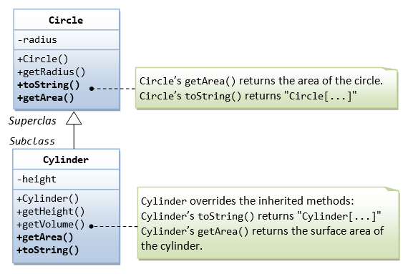

We can create an instance of Cylinder, and assign it to a Circle (its superclass) reference, as follows:
Circle c1 = new Cylinder(1.1, 2.2);
You can invoke all the methods defined in the Circle class for the reference c1, (which is actually holding a Cylinder object), e.g.
// Invoke superclass Circle's methods
c1.getRadius();
This is because a subclass instance possesses all the properties of its superclass.
However, you CANNOT invoke methods defined in the Cylinder class for the reference c1, e.g.
// CANNOT invoke method in Cylinder as it is a Circle reference!
c1.getHeight(); // compilation error
c1.getVolume(); // compilation error
This is because c1 is a reference to the Circle class, which does not know about methods defined in the subclass Cylinder.
c1 is a reference to the Circle class, but holds an object of its subclass Cylinder. The reference c1, however, retains its internal identity. In our example, the subclass Cylinder overrides methods getArea() and toString(). c1.getArea() or c1.toString() invokes the overridden version defined in the subclass Cylinder, instead of the version defined in Circle. This is because c1 is in fact holding a Cylinder object internally.
c1.toString(); // Run the overridden version!
c1.getArea(); // Run the overridden version!

Summary of polymorphism
- A subclass instance can be assigned (substituted) to a superclass' reference.
- Once substituted, we can invoke methods defined in the superclass; we cannot invoke methods defined in the subclass.
- However, if the subclass overrides inherited methods from the superclass, the subclass (overridden) versions will be invoked.

