If Exercises 4

- Create an application that determines if a given point in the Cartesian plane lies within the region created by two arcs as shown below.

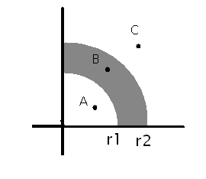
The Points A, C do not lie in the region created by the arcs of radius r1 and r2. Where as the point B lies in the region created by the arcs r1 and r2.

Note that the region only exists in the first quadrant of the Cartesian plane (positive x, and positive y). Your application MUST check to see whether the user has given a valid point to check as well.

Your Application must do the following:
Ask a user to enter radii of the two arcs in any order.
Ask a user to enter X and Y coordinates of a point and check whether this point belongs to the area between the arcs in the first quadrant of the Cartesian plane.

Example 1
Enter the two radii: 10 12
Enter the X coordinate of the point: 11
Enter the Y coordinate of the point: 0
Your point (11, 0) lies in the region.

Example 2
Enter the two radii: 12 7
Enter the X coordinate of the point: 3.4
Enter the Y coordinate of the point: 4
Your point (3.4, 4) does not lie in the region.

Example 3
Enter the two radii: 5 12
Enter the X coordinate: -3
Enter the Y coordinate: 4
Your point (-3, 4) does not lie in the region.

- Create a slot machine game application that acts as a simple slot machine. The computer “spins” 3 wheels, each consisting of the numbers 1,2 or 3. If all three numbers are 1, the user gets 4 tokens; if all are 2, the user gets 8 tokens; if all are 3, the user gets 12 tokens. If only 2 numbers are the same, the user gets 1 token. Display the results of “spin” and the number of tokens that user got.

Example 1
You got 3 1 3
You won 1 token

Example 2
You got 2 2 2
You won 8 tokens

