ASCII assignemnt.

- Print ASCII table from 1 to 100.
You output should look similar to:
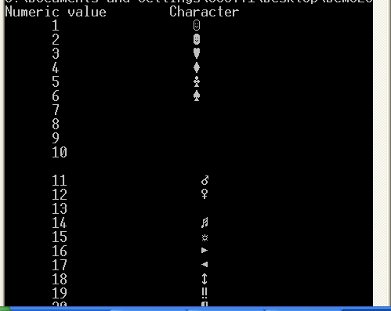

- Ask the user for the input and erase all the non-letter characters – spaces, commas, explanation marks and so on.
For example, if the user enters:
I don’t like this assignment!!#*($&#(*&
You should print
Idontlikethisassignment

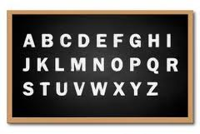
3. Caesar’s Cipher

In cryptography, a Caesar's cipher is one of the simplest and most widely-known encryption techniques. To code the message each letter in the plaintext is replaced by a letter some number of positions further down the alphabet. For example, with a shift of 3, A would be replaced by D, B would become E, and so on. If the end of the alphabet is reached, the letters should start from the beginning: X would become A, Y would become B and Z would become C.
Coding:
A→D; B→E; C→F; D→G; .... W→Z; X→A; Y→B; Z→C

Decoding:
D→A; E →B; F→C; G→D; .... Z→W; A→X; B→Y; C→Z

Any non-letters (like spaces, dots, comas and so on) will not change.
For example, DEVROXWHOB!! can be decoded as: ABSOLUTELY!!

That code can be easily broken if we know the shift value.

You are a spy who must use to computer to communicate with your spy partner and decode secret messages. You will be given two messages. The first input will contain a message that was encrypted using the Caesar Cipher. It will contain letter and punctuation (like spaces, dots, comas and so on). If the character is a letter, it will be upper case. The second input will be the decrypted first word of the encrypted message. You can use this word to find out the shift, used by your partner.

Sample Input #1
KHOOR WKHUH.
HELLO

Sample Output #1
HELLO THERE.
----------------------------------------------------

Sample Input #2
JKIKSHKX OY BKXXXXXXE IURJ....
DECEMBER

Sample Output #2
DECEMBER IS VERRRRRRY COLD....
-----------------------------------------------------

Sample Input #3
CAH RC. HXD'UU URTN RC.
TRY

Sample Output #3
TRY IT. YOU’LL LIKE IT.

