Scanner Exercises 2

- Ask the user for 3 marks and later for the name of the course. Display the course name with marks average.
For example,
Enter 3 marks: 90 95 87
Enter a course name: ICS3U
Your ICS3U average is 90.67
- Given the Cartesian plane coordinates for the centre of a circle (x1,y1) and a point on the circle’s circumference (x2,y2), calculate the area of the circle.
The input will contain four double values, each separated by a single space, x1,y1, x2 and y2 representing the coordinates. -10000 <= x1, y1, x2, y2 <= 10000
Display the area of the circle rounded to three decimal places.
For example,
Enter coordinates:
2 4 4 8
The area is: 62.832

Enter coordinates:
1 1 1 2
The area is: 3.142

Enter coordinates:
10.25 10.5 100 75.8
The area is: 38701.726
- Bonus:
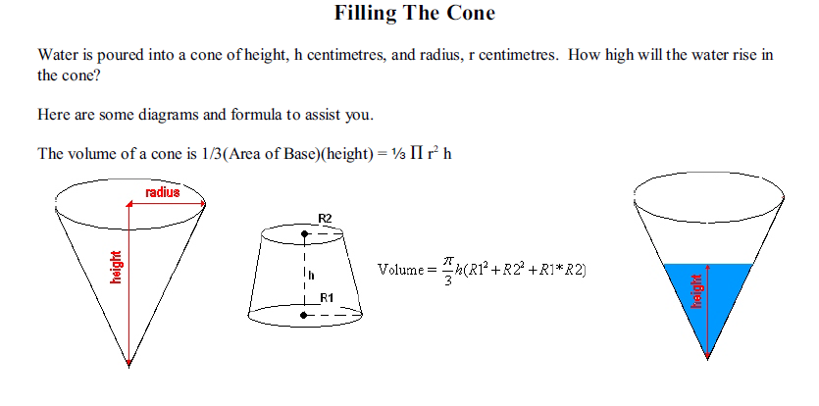

(Hint: I would use similar triangles instead of given formula)
Ask the user for the value of h – the height of the cone in centimetres, the value of r - the radius of the cone in centimeters, the value of v - the volume of the water poured into the cone in cubic centimeters ( the value will be 0< v <= 1/3 Pi r²h ) . You should calculate and display the height of the water in the cone.
For example,
Enter h,r and v: 10 10 100
The height is 4.57

Enter h,r and v: 10 10 50
The height is 3.63

Enter h,r and v: 20 20 250
The height is 6.2

